**Student Name: Katheryn Knutson**

**Lab Final**

1. **Final_2021FA_CSCP-28100-001 Intro To Networks**
2. **Topology**

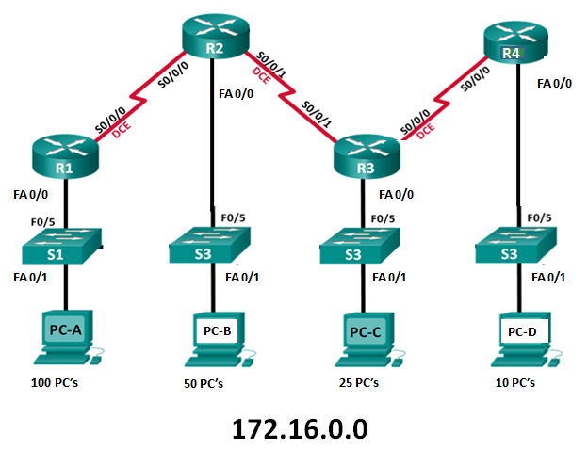

1. **Background / Scenario**

Configure network as specified by objective listed above. Lab time is 3 hours.

1. **Required Resources**

* 4 Routers (Cisco 2621xm) (Serial connections between routers)
* 4 Switches (Cisco 2960)
* 4 PCs (One PC per LAN representing larger networks. Each PC to receive last available IP Address for it respective network)
* Ensure connectivity / reach ability to all devices

1. **Addressing Table**

| **Device** | **Interface** | **IP Address** | **Subnet Mask** | **Default Gateway** |
| --- | --- | --- | --- | --- |
| R1 | FA 0/0 | 172.16.0.1 | 255.255.255.128 | N/A |
|  | S0/0/0 | 172.16.0.241 | 255.255.255.252 | N/A |
| R2 | FA 0/0 | 172.16.0.129 | 255.255.255.192 | N/A |
|  | S0/0/0 | 172.16.0.242 | 255.255.255.252 | N/A |
|  | S0/0/1 | 172.16.0.245 | 255.255.255.252 | N/A |
| R3 | FA 0/0 | 172.16.0.193 | 255.255.255.224 | N/A |
|  | S0/0/0 | 172.16.0.246 | 255.255.255.252 | N/A |
|  | S0/0/1 | 172.16.0.249 | 255.255.255.252 | N/A |
| R4 | FA 0/0 | 172.16.0.225 | 255.255.255.240 | N/A |
|  | S0/0/0 | 172.16.0.249 | 255.255.255.252 | N/A |
| S1 | VLAN 1 | 172.16.0.2 | 255.255.255.128 | 172.16.0.1 |
| S2 | VLAN 1 | 172.16.0.130 | 255.255.255.192 | 172.16.0.129 |
| S3 | VLAN 1 | 172.16.0.194 | 255.255.255.224 | 172.16.0.193 |
| S4 | VLAN 1 | 172.16.0.226 | 255.255.255.240 | 172.16.0.225 |
| PC-A | NIC | 172.16.0.126 | 255.255.255.128 | 172.16.0.1 |
| PC-B | NIC | 172.16.0.190 | 255.255.255.192 | 172.16.0.129 |
| PC-C | NIC | 172.16.0.222 | 255.255.255.224 | 172.16.0.193 |
| PC-D | NIC | 172.16.0.238 | 255.255.255.240 | 172.16.0.225 |

1. **Objectives**

**____ Part 1: Build & Cable Network as shown in the topology (5 points)**

**____ Part 2: Subnet the network most efficiently (complete table above) (20 points)**

**____ Part 3: Configure all devices with hostname as specified in topology (5 points)**

**____ Part 4: Configure all devices with password of cisco (no encrypted passwords) (10 points)**

**____ Part 5: Configure all devices with appropriate IP addresses (20 points)**

**____ Part 6: Configure all routers and switches to support SSH access (20 points)**

**____ Part 7: Configure all routers for Static Routing, RIP V2 or OSPF routing protocol(20 points)**

***All devices must be reachable via PING from any other device.***

***I did everything but part 6 correctly and for part 7 I chose RIP V2***

**172.16.0.0**

**Network A 100**

**Network B 50**

**Network C 25**

**Network D 10**

**Network E 2**

**Network F 2**

**Network G 2**

Network A 100 /25

Subnet Mask: 255.255.255.128

Network IP: 172.16.0.0

First IP: 172.16.0.1

Last IP: 172.16.0.126

Broadcast IP: 172.16.0.127

Network B 50 /26

Subnet Mask: 255.255.255.192

Network IP: 172.16.0.128

First IP: 172.16.0.129

Last IP: 172.16.0.190

Broadcast IP: 172.16.0.191

Network C 25 /27

Subnet Mask: 255.255.255.224

Network IP: 172.16.0.192

First IP: 172.16.0.193

Last IP: 172.16.0.222

Broadcast IP: 172.16.0.223

Network D 10 /28

Subnet Mask: 255.255.255.240

Network IP: 172.16.0.224

First IP: 172.16.0.225

Last IP: 172.16.0.238

Broadcast IP: 172.16.0.239

Network E 2 /30

Subnet Mask: 255.255.255.252

Network IP: 172.16.0.240

First IP: 172.16.0.241

Last IP: 172.16.0.242

Broadcast IP: 172.16.0.243

Network F 2 /30

Subnet Mask: 255.255.255.252

Network IP: 172.16.0.244

First IP: 172.16.0.245

Last IP: 172.16.0.246

Broadcast IP:172.16.0.247

Network G 2 /30

Subnet Mask: 255.255.255.252

Network IP: 172.16.0.247

First IP: 172.16.0.248

Last IP: 172.16.0.249

Broadcast IP: 172.16.0.250